A920 Quick Start Guide

Contactless Reader
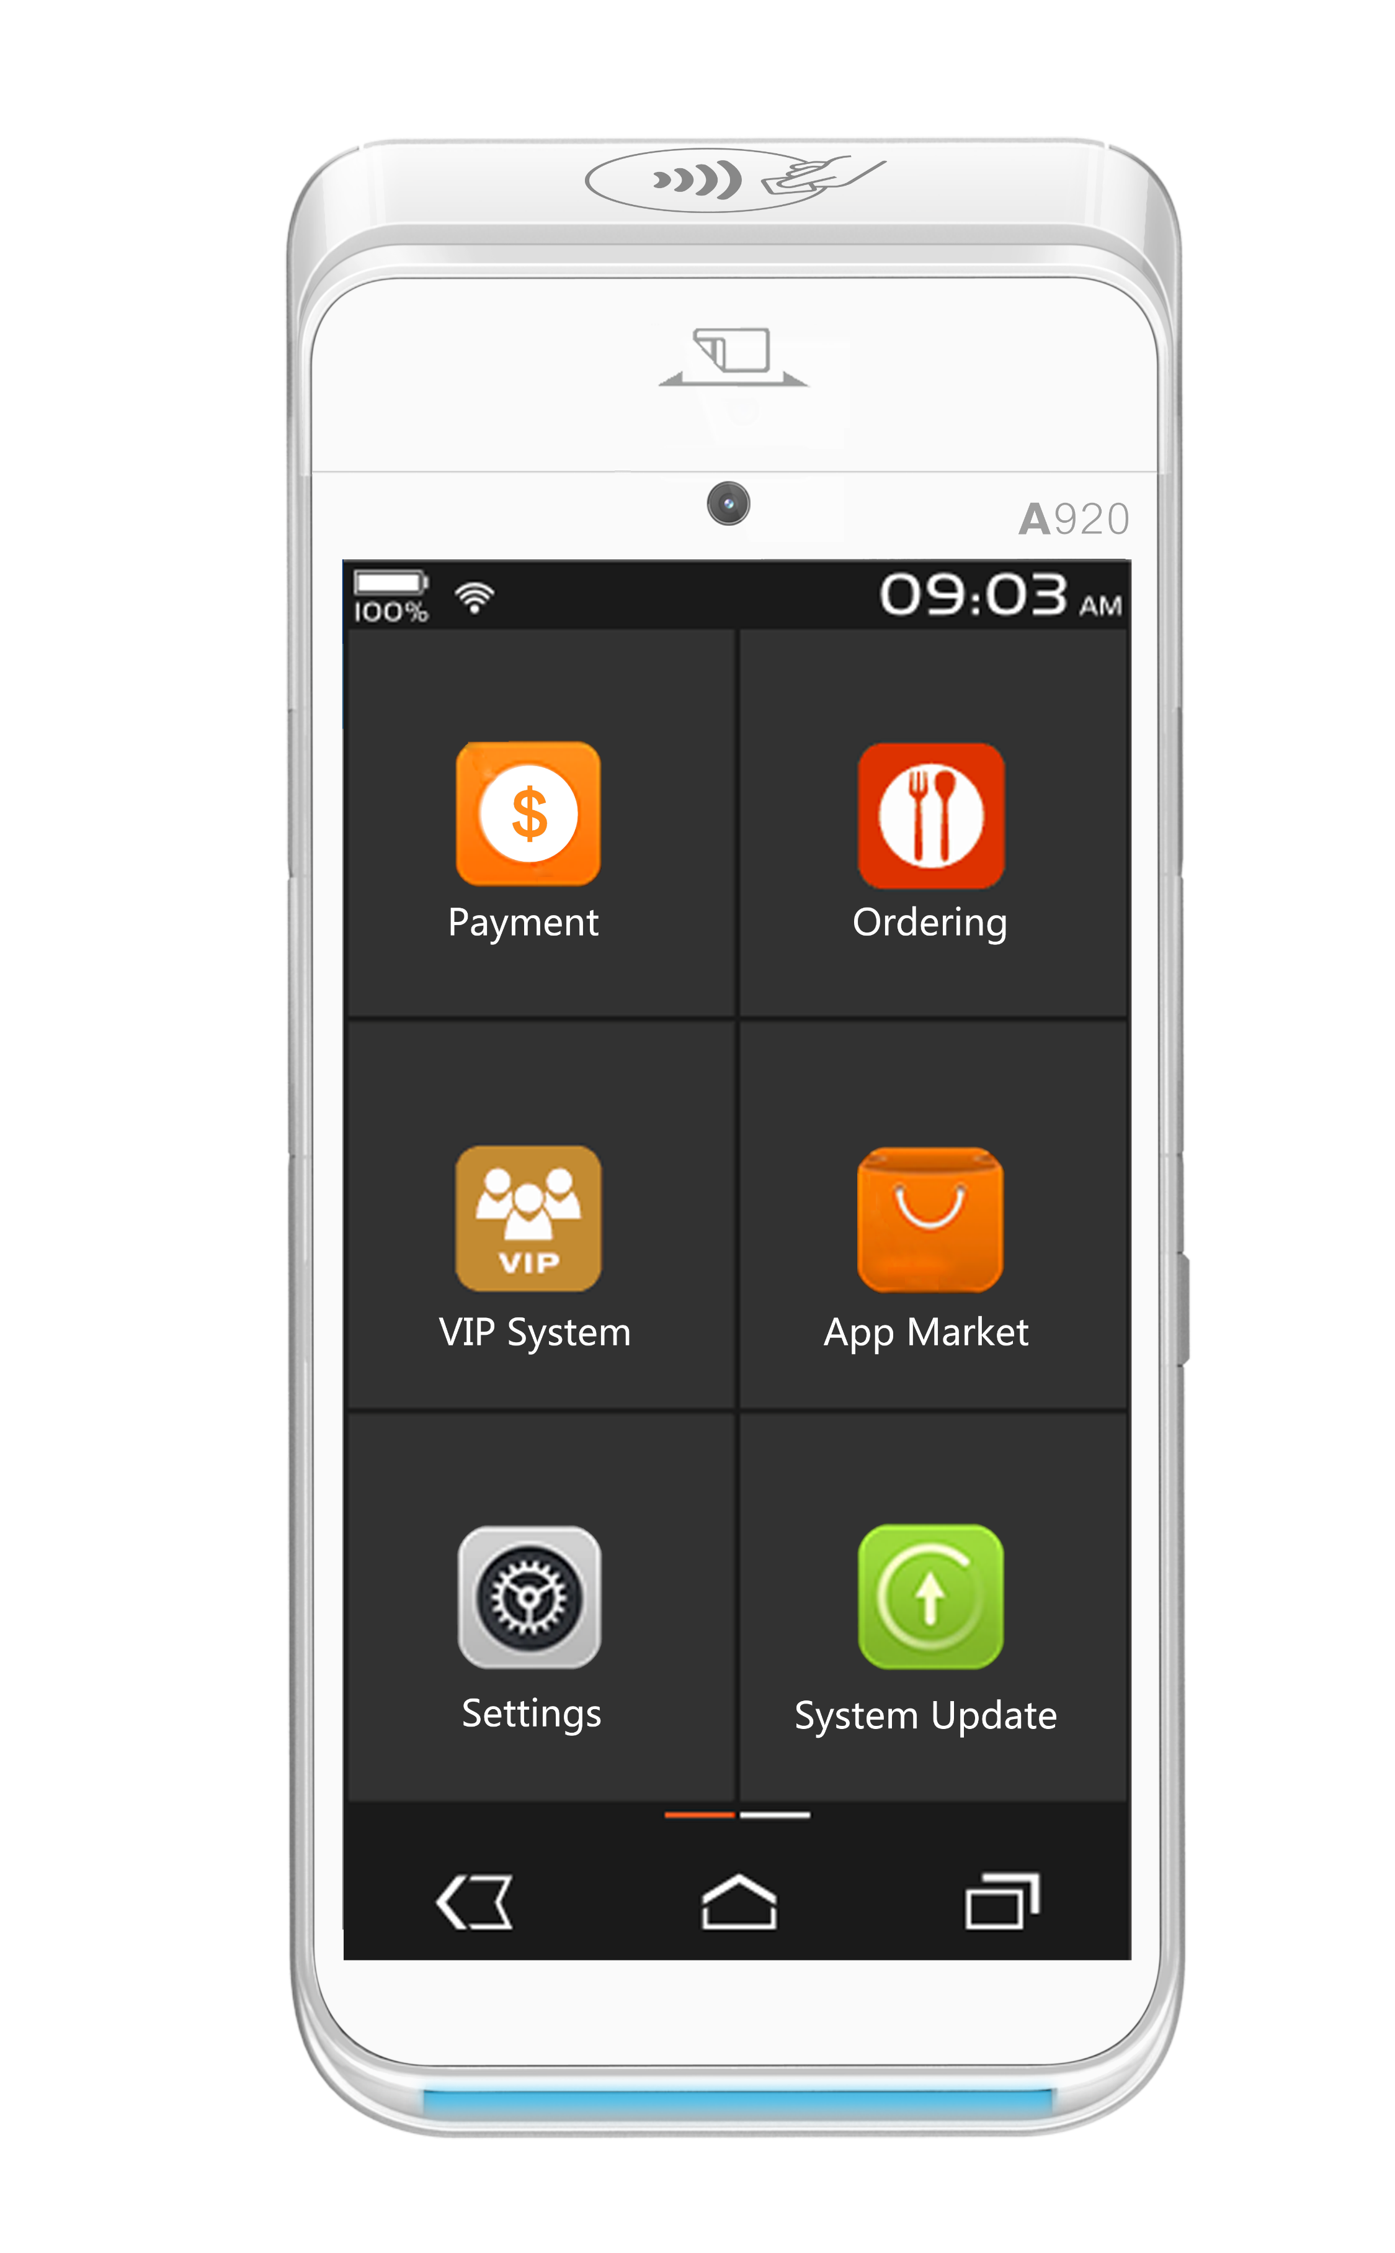

Mag Stripe Reader

Volume Down Button
Volume Up Button

Power Button

Micro USB Port

Card Reader

What is in the box?

1 x PAX A920 Terminal
1 x AC Power Adapter
1 x Micro USB to USB Type-A Cable
1 x Thermal Paper Roll
1 x PAX Installation Guide

Physical Set Up of the Device

Changing the Paper Roll

To remove the thermal paper, turn the device over and pull the Paper Cover Latch away from the device. The top section of the device will pivot downwards. To remove the paper, simply pull the paper roll out.

To install a new thermal paper roll, insert paper roll with the paper poking out of the top of the device. Then, close the lid until the lid snaps into place. Ensure the lid is fully closed so that the paper roll fully engages the paper. Tear off any excess paper.

Changing the Battery

To remove and the battery, turn the device over to show the back of the terminal. Then, locate the battery cover and slide the open/close slide switch to the right. Next, lift the battery cover from the terminal, and pivot the lid upwards to remove. Finally, lift the battery from the bottom edge, swing upwards from the bottom and pull out.

To install a battery, first remove the protective cover over the battery connectors. Next, insert the battery with the gold connectors towards the top right side. Slide the battery upwards, whilst carefully pushing the bottom into place. Insert the top of the battery lid into the lid hinges. Then, lower the bottom of the lid cover until it is flush with the case. Finally, slide the lid switch to the left to lock the battery cover.

Power On/Off and Sleep Mode

Power On

Press and hold the power button for three seconds until the screen the screen powers on.

Power Off

Press and hold the power button for three seconds until the power menu is shown. Tap Power off, and then Power off again. A “shutting down…” message will show when the terminal is turning off.

Sleep Mode

To put the device in or wake the device from sleep mode, click the power button.

Connecting to WiFi

To connect the device to Wi-Fi, please click the three dots in the top right-hand corner of the screen and select Wi-Fi Settings. The device will then be redirected to the Wi-Fi settings page.

The device will automatically search and bring up available Wi-Fi networks. Please complete the connection process. When this is complete, click the back arrow on the bottom left of the screen.

Conducting a Sale/Refund

To conduct a sale/refund, from the main menu choose Sale/Refund.

Key in the amount of the sale/refund and select Done.
You will be prompted to Tap, Swipe or Insert; or complete the transaction with the “Card Not Present feature”.

If the customer is present, please ask the customer to do one of the following:
- Tap the card on the contactless reader
- Swipe the card through the magstripe reader
- Insert card into the card reader
If the customer is not present, select the Card Not Present button:
- Key in the card number and expiry date and select Done
- Key in the CSC number and select Done

If all details are valid the terminal will process the transaction.

If the transaction has been approved a green tick is displayed. If the transaction has failed a red cross is displayed.

The sale/refund process is now complete, the application will return to the main menu.

