A920 User Guide
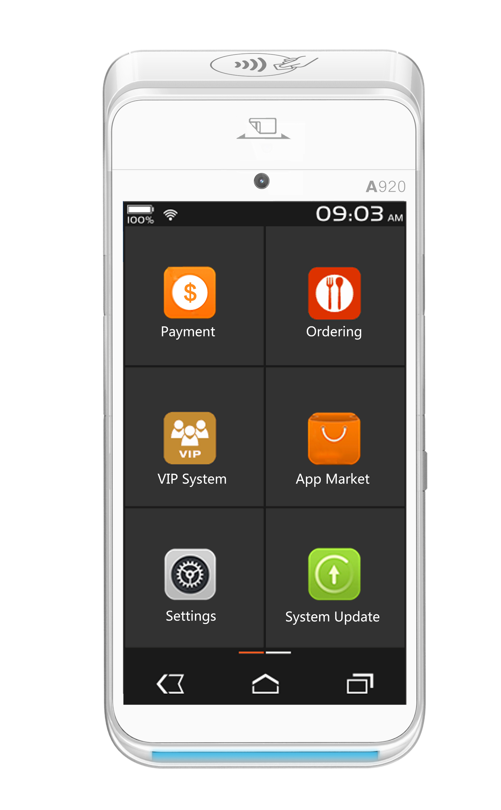
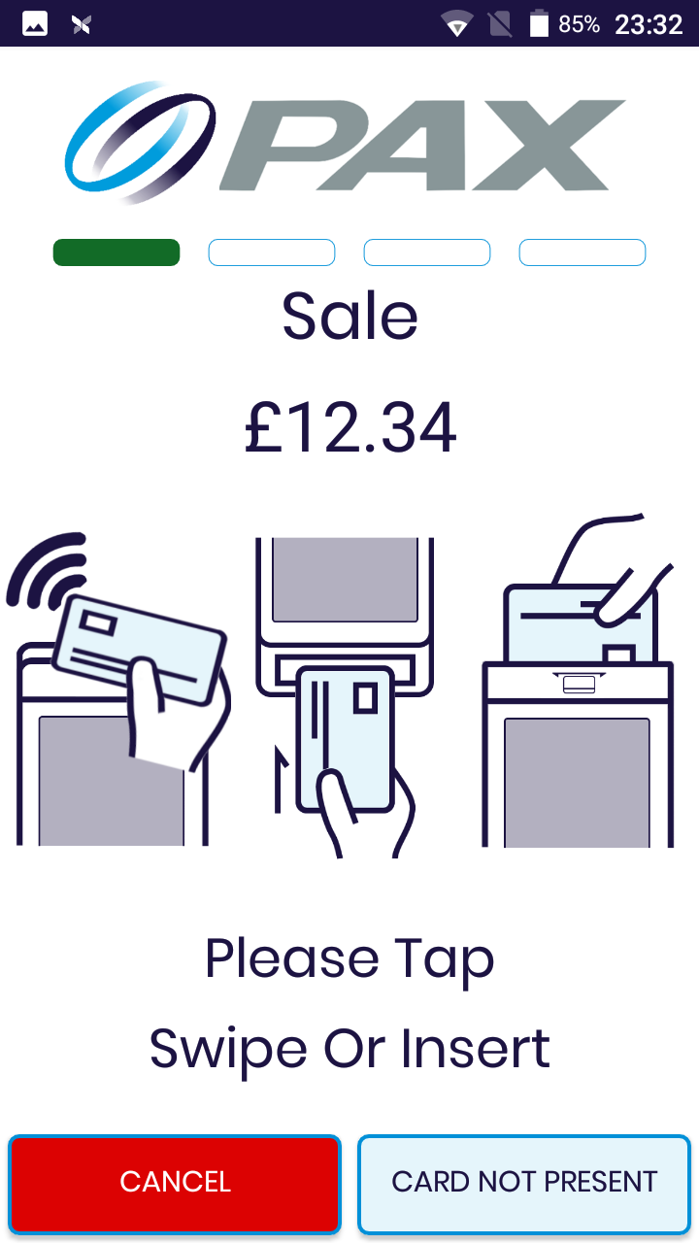

Contents
1. What is in the box? 1
2. Buttons and Functions 2
3. Physical Set up of the Device 3
3.1. Changing the Paper Roll 3
3.2. Changing the Battery 4
4. Power On/Off and Sleep Mode 5
4.1 Power On 5
4.2 Power Off 5
4.3 Sleep Mode 5
5. Connecting to WiFi 6
6. Using the POSitive Payment application 7
6.1 Features of POSitive 8
6.2 Conducting a Sale 9
6.3 Conducting a Sale with Gratuity 11
6.4 Conducting a Sale with Cashback 14
6.5 Conducting a Refund 16
6.6 Conducting a Sale or Refund when the customer is not present 18
6.7 Reprinting and viewing Receipts 19
6.8 Viewing System Information 20
6.9 Reconciliation (Z Report) 21
6.10 Generating an X report 21
6.11 Viewing the transaction history 21

What is in the box?

1 x PAX A920 Terminal

1 x AC Power Adapter
1 x Micro USB to USB Type-A Cable

1 x Thermal Paper Roll

1 x PAX Installation Guide

Buttons and Functions

Contactless reader

Magstripe reader

Volume Down Button
Volume up Button

Power Button

Micro USB Port

Card Reader

Physical Set up of the Device

Changing the Paper Roll

To remove the thermal paper, turn the device over and pull the Paper Cover Latch away from the device. The top section of the device will pivot downwards. To remove the paper, simply pull the paper roll out.

To install a new thermal paper roll, insert paper roll with the paper poking out of the top of the device, adhering to the orientation shown in the paper roll holder. Then, close the lid until the lid snaps into place.

Ensure the lid is fully closed so that the paper roll fully engages the paper. Tear off any excess paper.

Paper Cover Latch

Changing the Battery

To remove and the battery, turn the device over to show the back of the terminal. Then, locate the battery cover and slide the open/close slide switch to the right. Next, lift the battery cover from the terminal, and pivot the lid upwards to remove. Next, lift the battery from the bottom side and swing it upwards from the bottom and pull out.

To install a battery, first remove the protective cover over the battery connectors. Next, insert the battery with the gold connectors towards the top right side. Slide the battery upwards, whilst carefully pushing the bottom into place. Insert the top of the battery lid into the lid hinges. Then, lower the bottom of the lid cover until it is flush with the case. Finally, slide the lid switch to the left to lock the battery cover.

Slide Switch

Power On/Off and Sleep Mode

Power On

Press and hold the power button for three seconds until the screen the screen powers on.

Power Off

Press and hold the power button for three seconds until the power menu is shown. Tap Power off, and then Power off again. A “shutting down…” message will show when the terminal is turning off.

Sleep Mode

To put the device in or wake the device from sleep mode, click the power button.

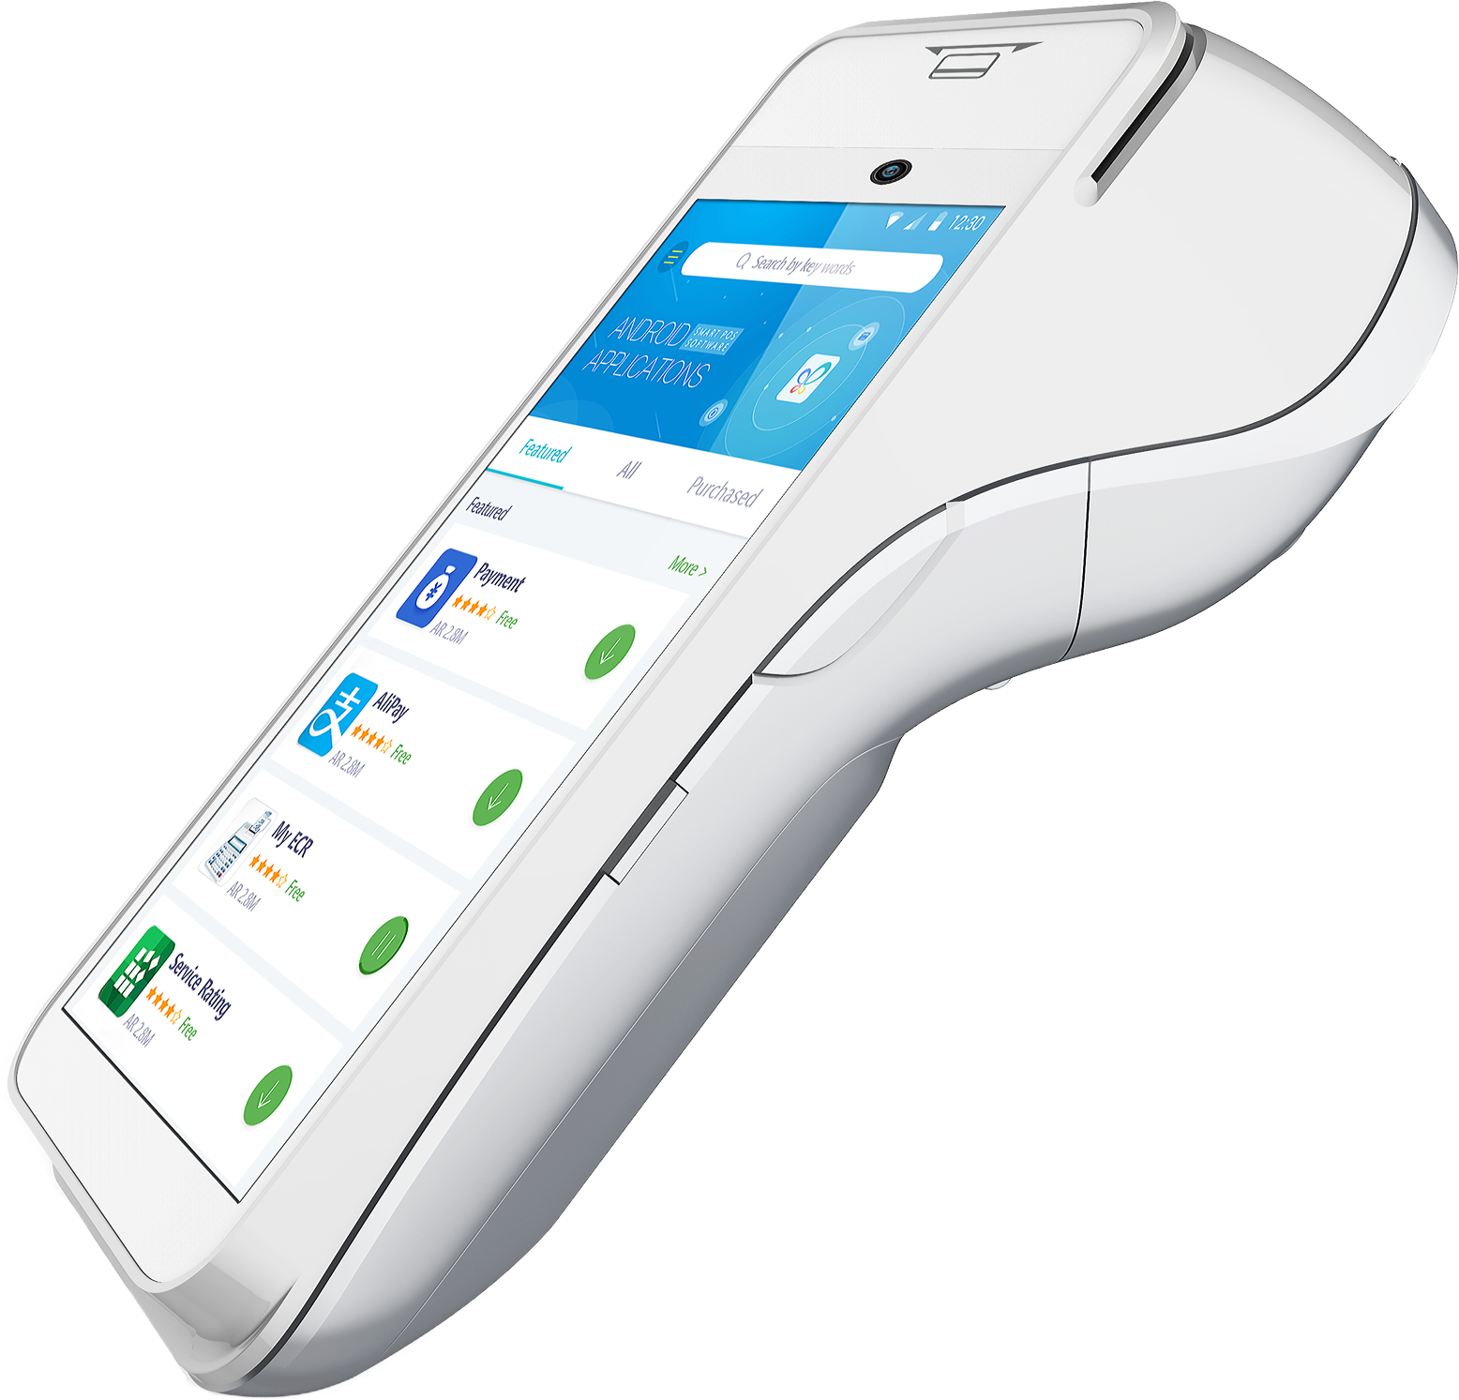

Power Button

Connecting to WiFi

To connect the device to Wi-Fi, please click the three dots in the top right-hand corner of the screen, and select Wi-Fi Settings, as shown in Figure 1. The device will then be redirected to the Wi-Fi settings page.

The device will automatically search and bring up available Wi-Fi networks. Please complete the connection process and click the back arrow on the bottom left of the screen when complete, as shown in Figure 2.

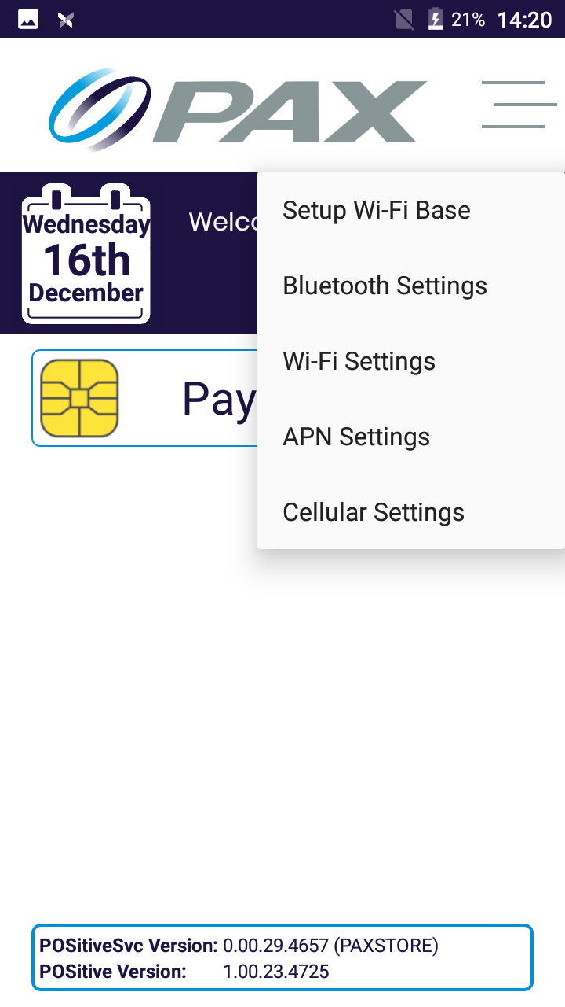
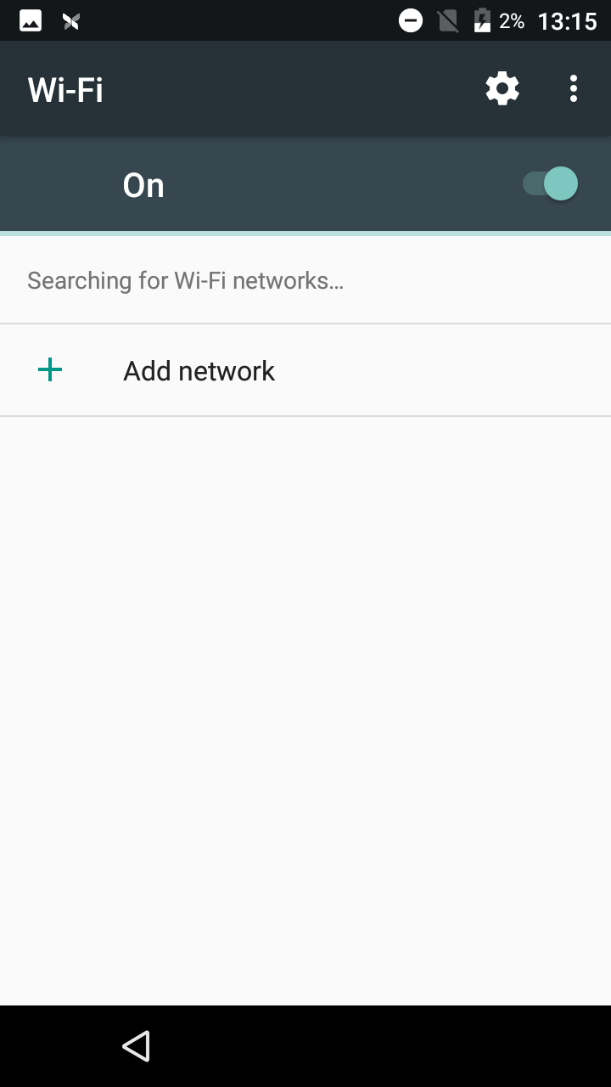
Figure 2
Figure 1

Using the POSitive Payment application

From the bootup screen please click “Payments”, once the application has loaded you will be prompted for an ID and Password, as shown in Figure 3. By default, both these fields are 1234. You will then be prompted to set a new password. This is the manager account. Once you are logged you will be at the main menu of the POSitive payment application, this is shown in Figure 4.

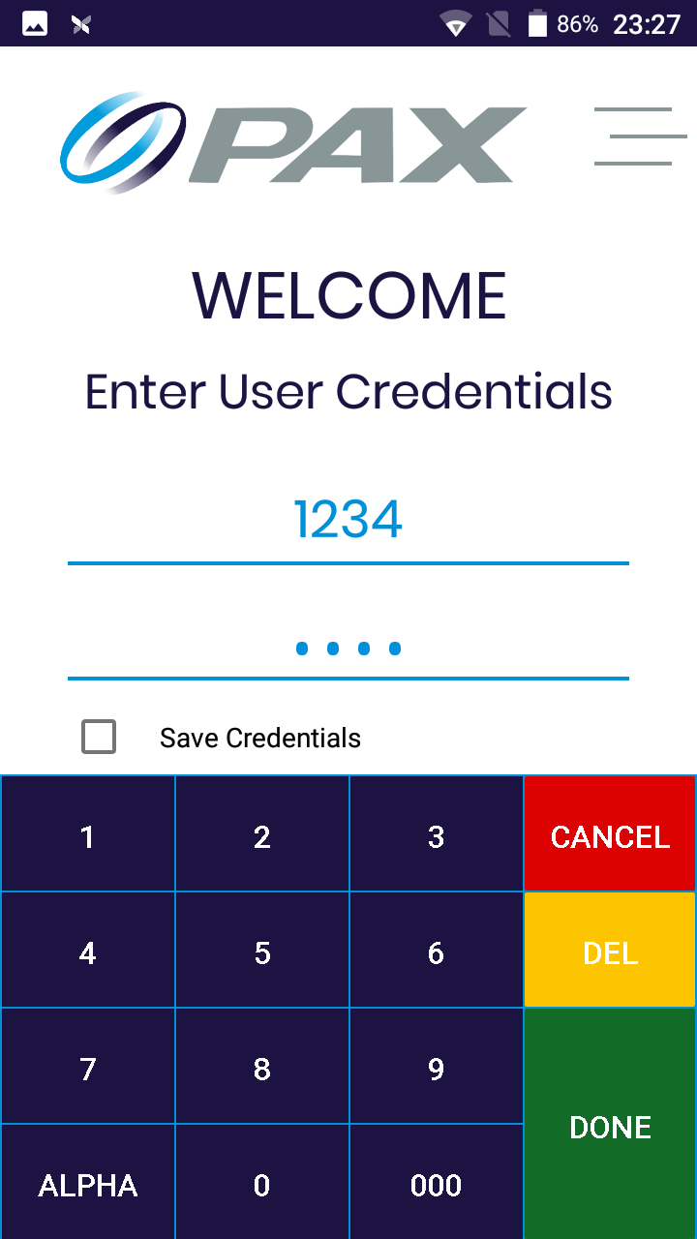
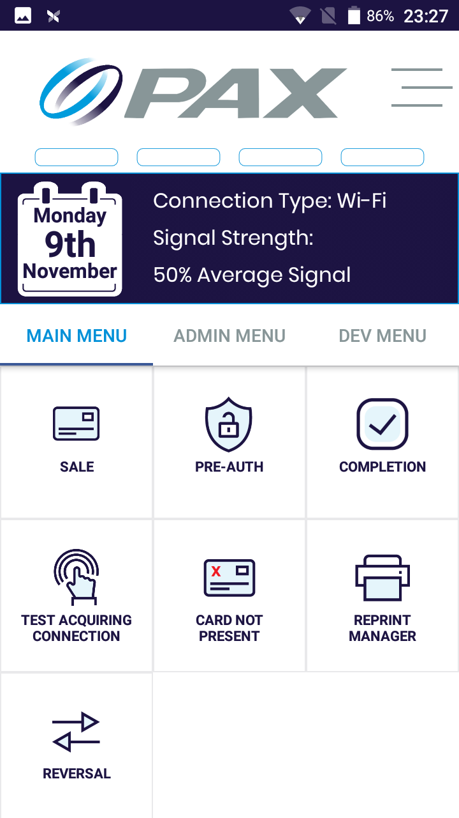

Figure 4
Figure 3

The main menu shown in Figure 4 is the “home screen” of the POSitive payment app and will be heavily referenced in the remainder of this document.

Features of POSitive

From the Main Menu you are able to:

- Conduct sales (with gratuity and cashback)
- Conduct refunds
- Conduct card not present sales
- Reprint and view receipts
- Test the acquiring connection

From the Admin Menu you are able to:

- Print software and hardware information
- Reconcile with Z reports
- Generate X reports
- Print the transaction history
- Manage user accounts

Conducting a Sale

To conduct a sale, from the main menu shown in Figure 4, choose Sale.

Key in the amount of the sale and select Done, as shown in Figure 5.
You will be prompted to Tap, Swipe or Insert; or complete the transaction with the “Card Not Present feature”, as shown in Figure 6.

If the customer is present, please ask the customer to do one of the following:
- Tap the card on the contactless reader
- Swipe the card through the magstripe reader
- Insert card into the card reader
If the customer is not present, select the Card Not Present button:
- Key in the card number and expiry date and select Done
- Key in the CSC number and select Done

If all details are valid the terminal will process the transaction.

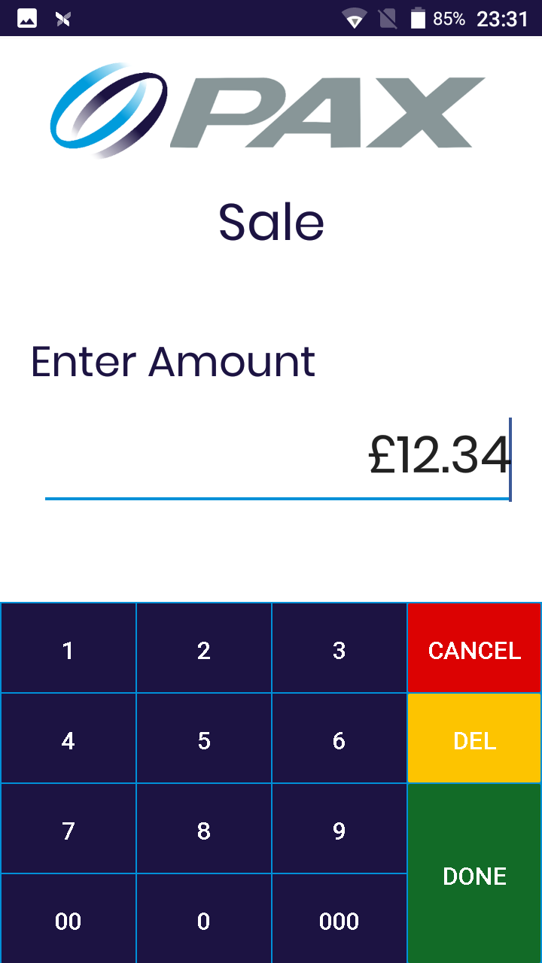
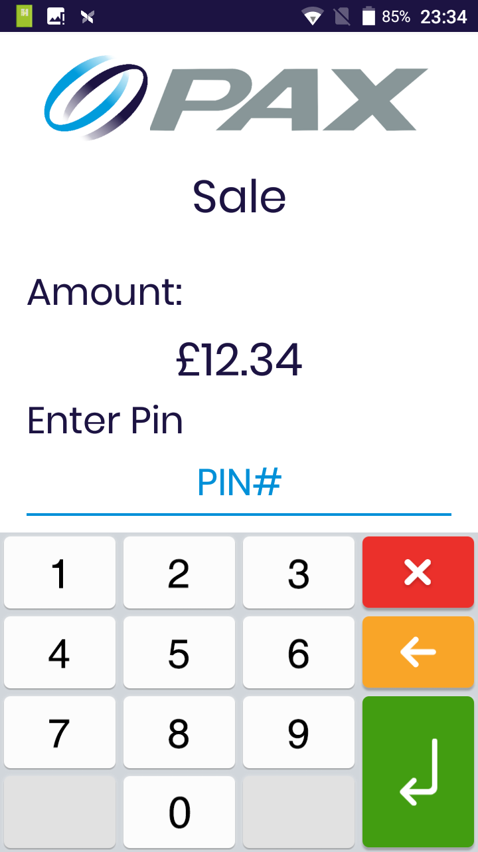
Figure 7
Figure 6
Figure 1
Figure 5
If the transaction has been approved a green tick is displayed, as shown in Figure 8. If the transaction has failed a red cross is displayed, as shown in Figure 9.

You will then be prompted to print the Cardholder receipt, as shown in Figure 10. Following this the merchant receipt will print.
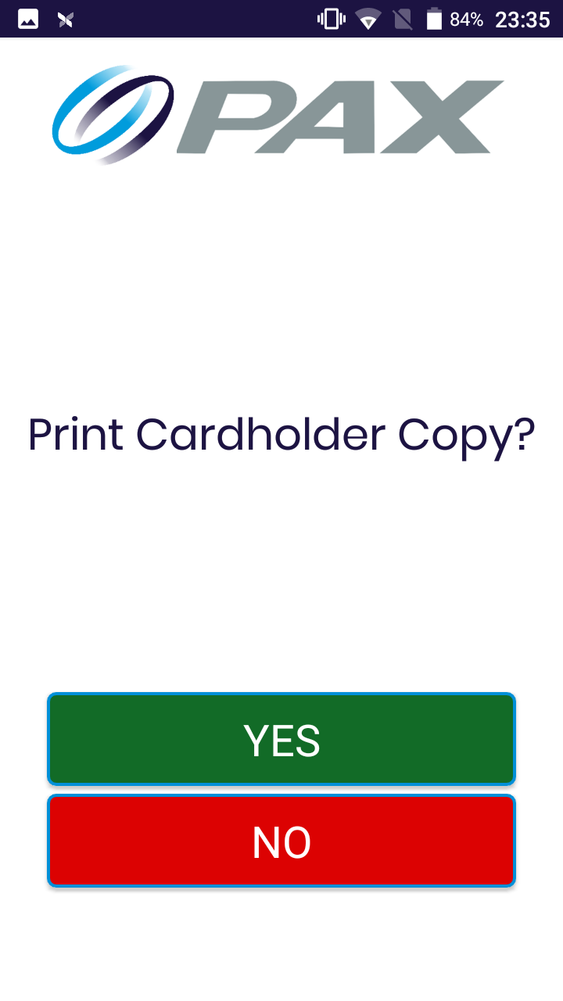
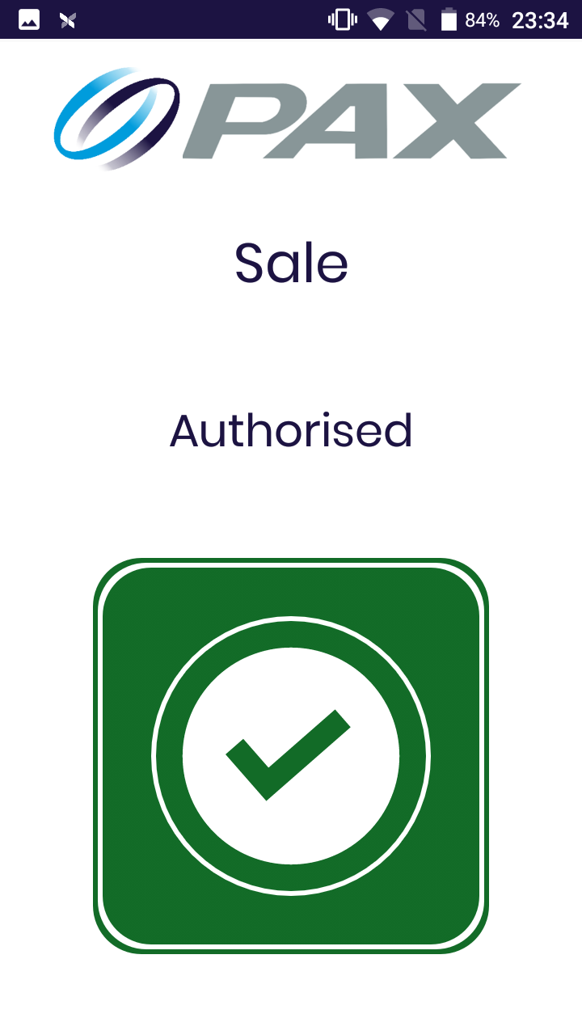
Figure 9
Figure 10
Figure 8

The sale process is now complete, the application will return to the main menu.

Conducting a Sale with Gratuity

To conduct a sale with gratuity, from the main menu shown in Figure 4, choose Sale.

Key in the amount of the sale and select Done, as shown in Figure 13.

If gratuity is enabled you will then be prompted to add a gratuity, as shown in Figure 11. If yes is selected you will be asked to select the gratuity amount, as shown in Figure 12. Once the amount is chosen please select accept.
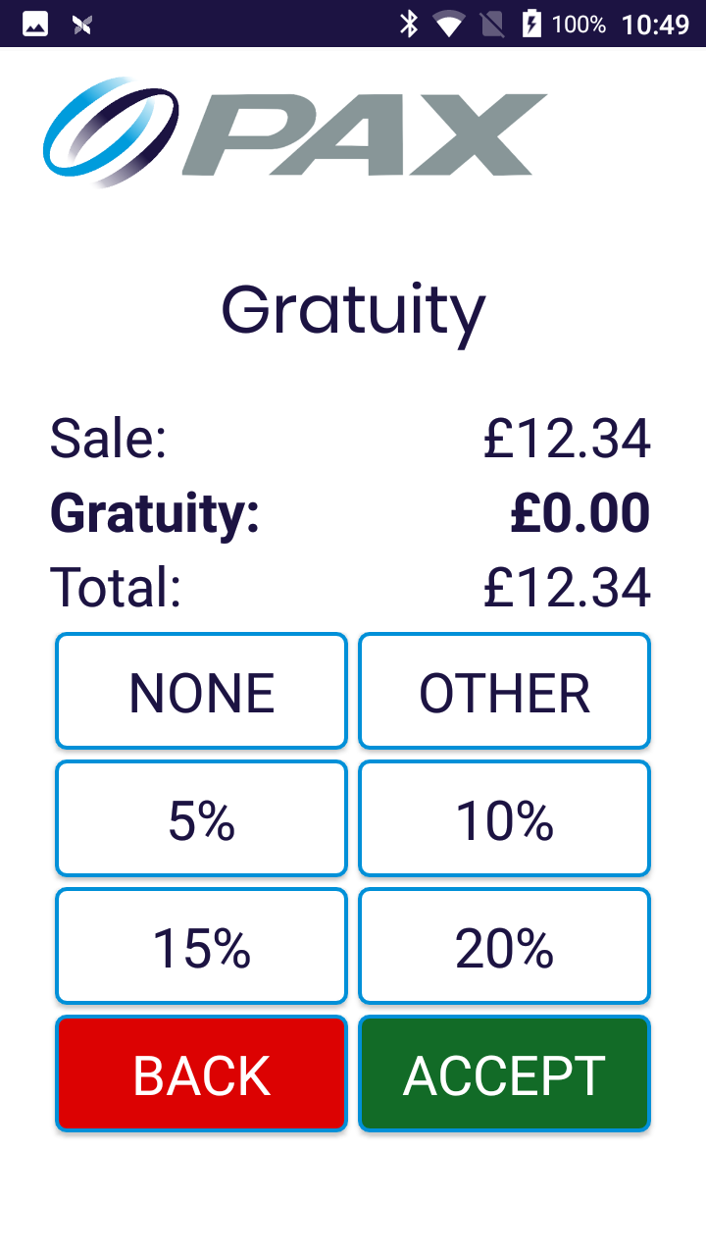

Figure 11
Figure 12

You will be prompted to Tap, Swipe or Insert; or complete the transaction with the “Card Not Present feature”, as shown in Figure 14.

If the customer is present, please ask the customer to do one of the following:
- Tap the card on the contactless reader
- Swipe the card through the magstripe reader
- Insert card into the card reader
If the customer is not present, select the Card Not Present button:
- Key in the card number and expiry date and select Done
- Key in the CSC number and select Done

If all details are valid the terminal will process the transaction.

Figure 15
Figure 14
Figure 13
If the transaction has been approved a green tick is displayed, as shown in Figure 16. If the transaction has failed a red cross is displayed, as shown in Figure 17.

You will then be prompted to print the Cardholder receipt, as shown in Figure 18. Following this the merchant receipt will print.
Figure 17
Figure 18
Figure 16

The sale process is now complete, the application will return to the main menu.

Conducting a Sale with Cashback

To conduct a sale with cashback, from the main menu shown in Figure 4, choose Sale.

Key in the amount of the sale and select Done, as shown in Figure 13.

You will be prompted to Tap, Swipe or Insert; or complete the transaction with the “Card Not Present feature”, as shown in Figure 19.

As cashback can only be processed through the Card reader or Magstripe reader, please ask the customer to do one of the following:

- Swipe the card through the magstripe reader
- Insert card into the card reader
If cashback is enabled you will then be prompted if Cashback is required, as shown in Figure 20. If yes is selected you will be asked to input the cashback amount, as shown in Figure 21. Once the amount is chosen please select Yes.
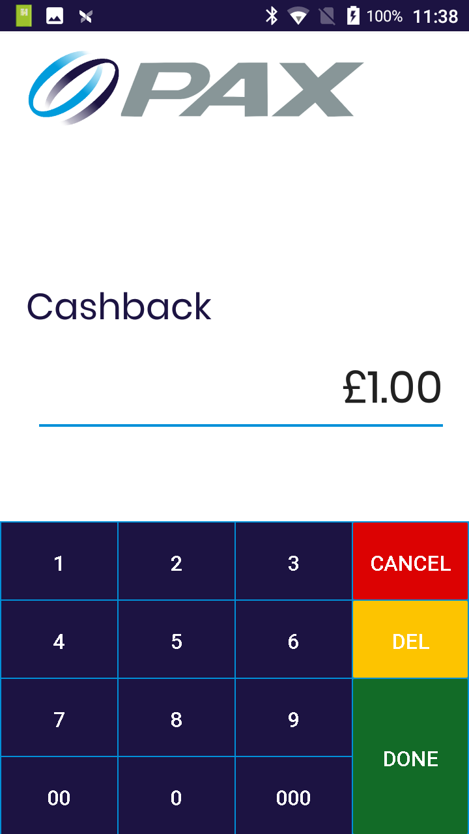
Figure 21
Figure 19
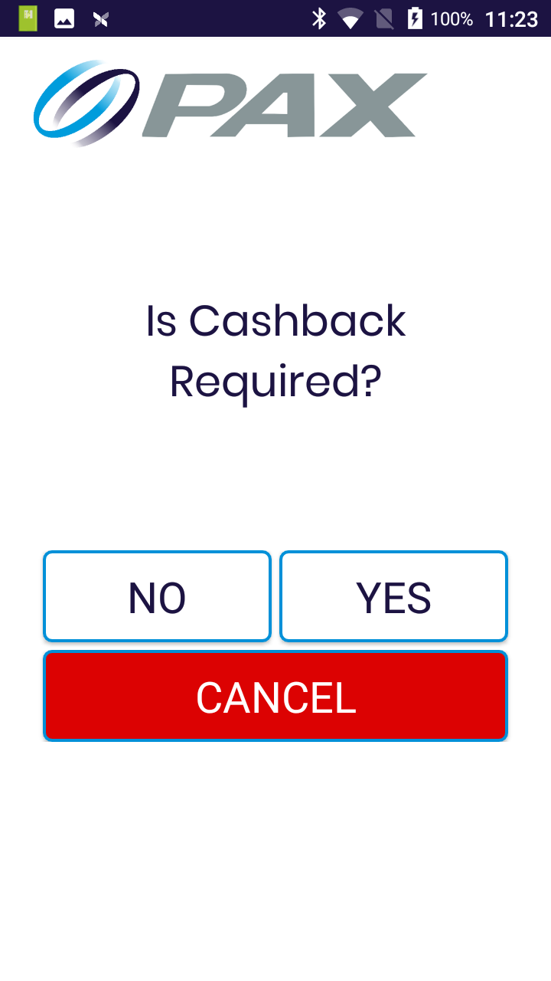
Figure 20
Please ask the customer to enter their PIN code, if all details are valid the terminal will process the transaction.

If the transaction has been approved a green tick is displayed, as shown in Figure 22. If the transaction has failed a red cross is displayed, as shown in Figure 23.

The terminal will always print the card holder receipt with a cashback transaction.

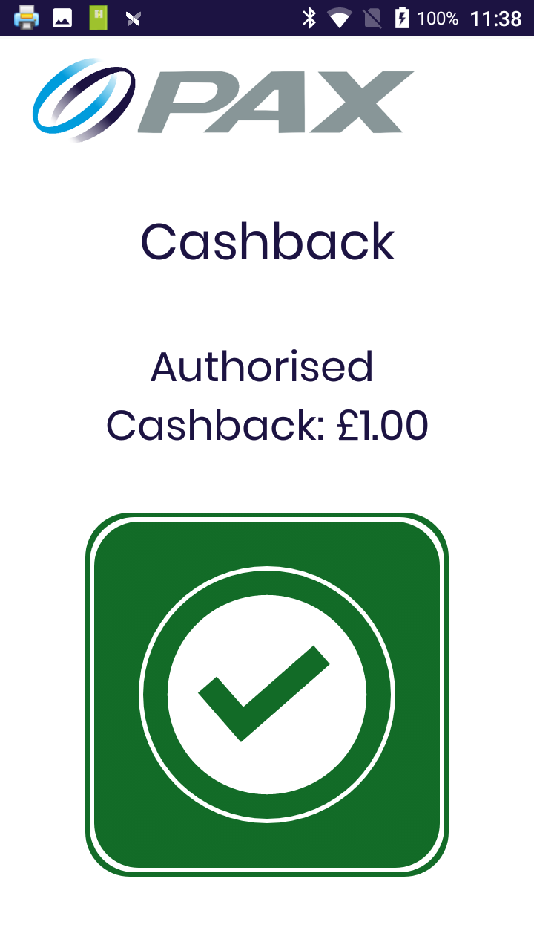
Figure 22

Figure 23

The sale process is now complete, the application will return to the main menu.

Conducting a Refund

To conduct a refund, from the main menu shown in Figure 4, choose Refund.

Key in the amount of the refund and select Done, as shown in Figure 24.
You will be prompted to Tap, Swipe or Insert; or complete the transaction with the “Card Not Present feature”, as shown in Figure 25.

If the customer is present, please ask the customer to do one of the following:
- Tap the card on the contactless reader
- Swipe the card through the magstripe reader
- Insert card into the card reader
If the customer is not present, select the Card Not Present button:
- Key in the card number and expiry date and select Done
- Key in the CSC number and select Done

If all details are valid the terminal will process the transaction.

Refund

Refund
Refund

Figure 26
Figure 25
Figure 9
Figure 24
If the refund has been approved a green tick is displayed, as shown in Figure 27. If the transaction has failed a red cross is displayed, as shown in Figure 28.

You will then be prompted to print the Cardholder receipt, as shown in Figure 29. Following this the merchant receipt will print.
Figure 28
Figure 29
Figure 27
Refund

Refund

The refund process is now complete, the application will return to the main menu.

Conducting a Sale or Refund when the customer is not present

To conduct a sale or refund if the customer is not present, from the main menu shown in Figure 4, choose Card Not Present.

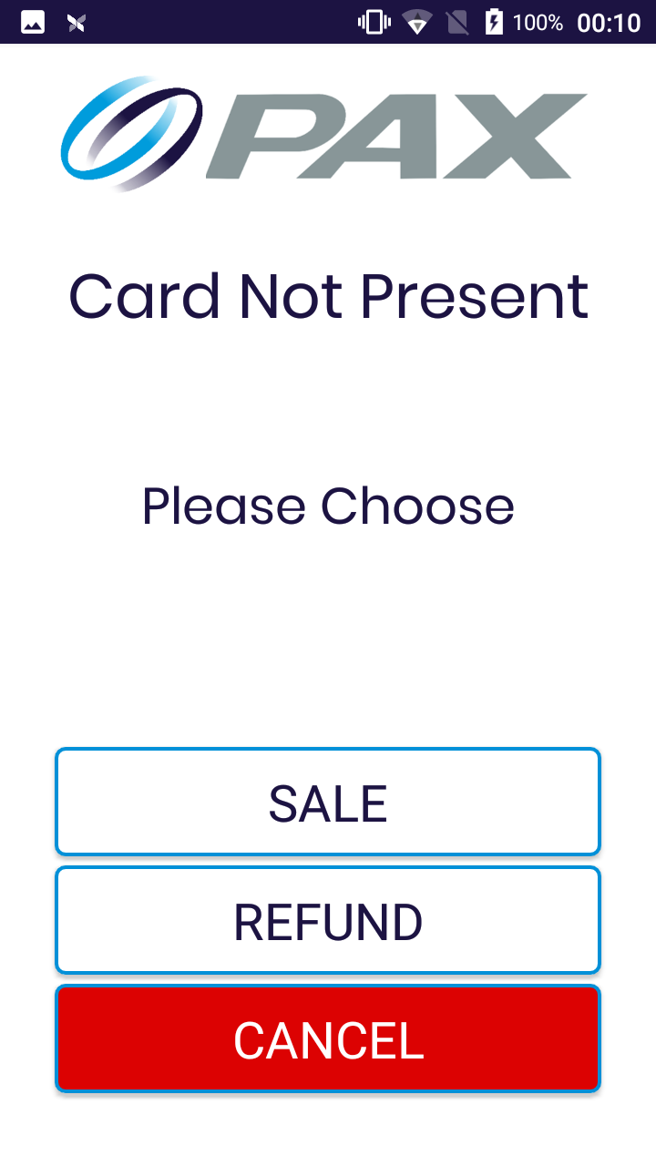

Figure 30

Choose either Sale or Refund, the terminal will redirect to a secure payment screen
- Type in the amount
- Type in the card details
- Enter optional reference
- Select Start Transaction

If all details are valid the terminal will process the transaction.

If the transaction has been approved a green tick is displayed. If the transaction has failed a red cross is displayed.

You will then be prompted to print the Cardholder receipt. Following this the merchant receipt will print.

The sale or refund process is now complete, the application will return to the main menu

Reprinting and viewing Receipts

To reprint and view previous receipts, from the main menu shown in Figure 4, choose Reprint Manager.

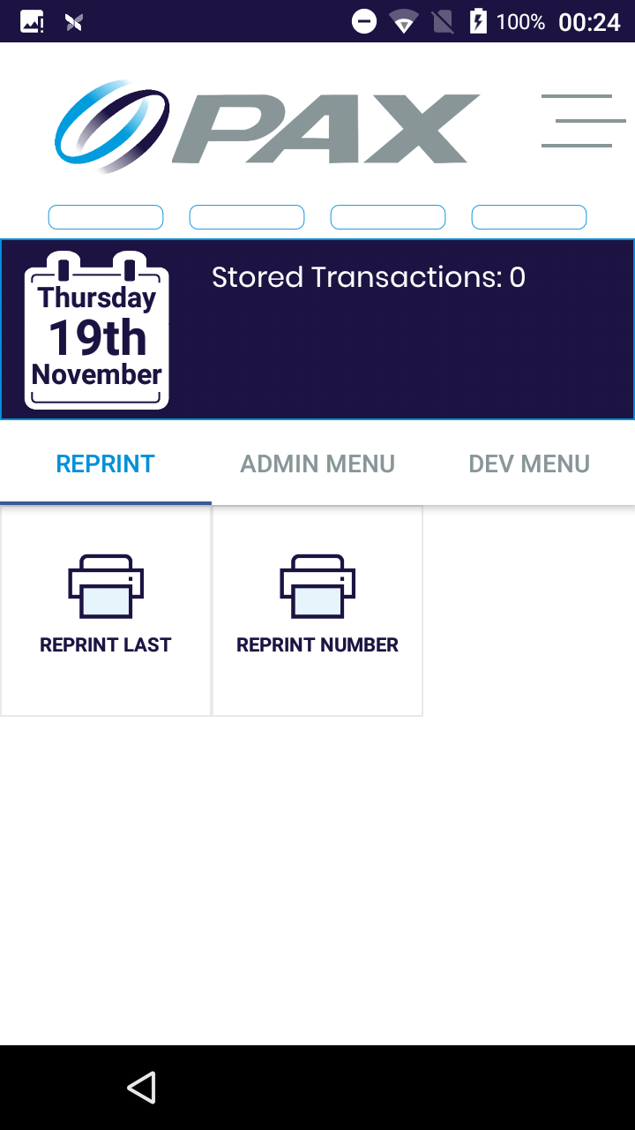
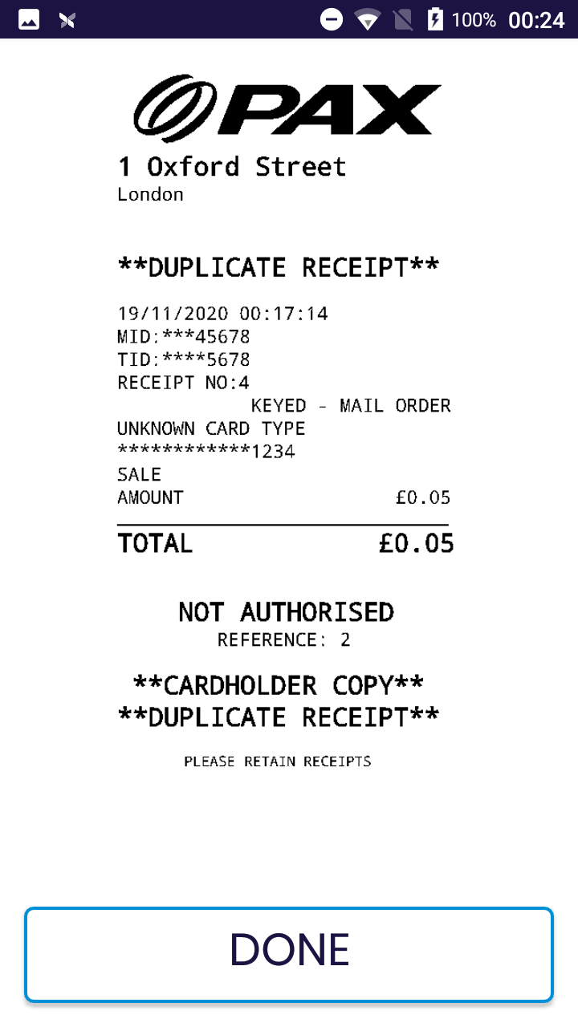
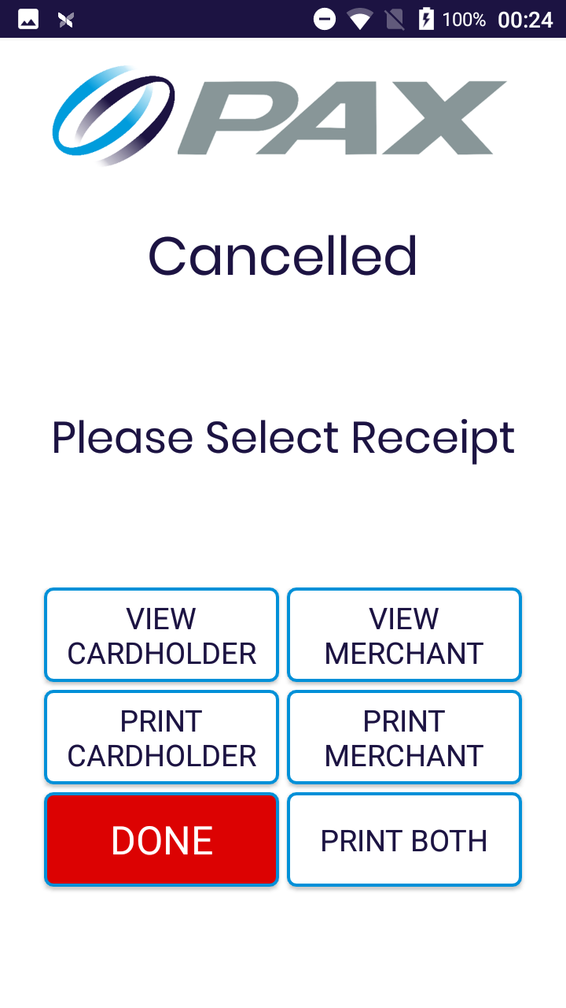
Figure 31
Figure 33
Figure 32

You are able to print the last receipt, or choose a specific receipt using the receipt number, as shown in Figure 31. If you choose Reprint Number, you will be prompted to provide the receipt number before continuing.

After choosing Reprint Last or entering the receipt number, the receipt menu will show as shown in Figure 32. You are able to view the receipts on the screen as shown in Figure 33, or choose to print the receipts. Once you are finished, press done.

The application will return to the main menu.

Viewing System Information

To view the System Information, from the main menu shown in Figure 4, swipe across to the admin menu and choose System Info. The device will print various information that can be used for issue diagnosis.

The System Info printed is:

Username | The username of the currently logged in user
User ID | The user ID of the currently logged in user
POS ID | The Terminal ID (TID)
POSitive Version | The version of POSitive Payment Application
MID | The Merchant ID
Connection Type | The connection type e.g. WiFi, Ethernet
Firmware Version of the Terminal | The base software of the terminal e.g. Paydroid 7.1
PTID | The Permanent Terminal ID (Serial number)
Terminal Serial Number | The Serial number of the device
Terminal Model | The device model number e.g. A920Pro
Reconciliation time | The time of the last reconciliation (Z Report)
POSitive Version | The version of POSitive Payment Application
EMV enabled | If EMV processing is currently enabled or disabled
APN Name (SIM 1) | The name of the APN in SIM 1 e.g. 02, Vodafone
APN (SIM 1) | The APN details of SIM 1 e.g. mobile.o2.co.uk
APN Name (SIM 2) | The name of the APN in SIM 2 e.g. 02, Vodafone
APN (SIM 2) | The APN details of SIM 1 e.g. mobile.o2.co.uk
Current SIM | What SIM is currently being used
Date | The date of the device
Time | The time of the device

Reconciliation (Z Report)

To generate a Z report, from the main menu shown in Figure 4, swipe across to the admin menu and choose Z Report (End of Day). This will print the report.

The Z Report is the end of day report, used for reconciliation purposes, and is performed when the store closes for the day. When performed, it will print a Z report and reset all totals back to zero in preparation of the store re-opening.

The Z report contains the sales figure of the day, the refunds figure and the net total of these amounts. It will also show the net total of each card scheme for the day. The date and time of the Z report was taken as well as the serial number of the terminal is also shown.

To reprint the Z report, from the main menu shown in Figure 4, swipe across to the admin menu and choose Reprint Z Report.

Generating an X report

To generate a X report, from the main menu shown in Figure 4, swipe across to the admin menu and choose X Report (End of Shift). This will print the report.

An X report and Z report contains the same information but the X report does not reset the totals back to zero. The report can be taken any time of day to the see the current sales, refunds and net total amount of the day, without affecting any of the records of the system.

Viewing the transaction history

To print the transaction history of the terminal from the main menu shown in Figure 4, swipe across to the admin menu and choose History Report. This will print the report.

The transaction history report contains the date and time of the report and the serial number of the terminal.

For each transaction the report will show:
Transaction Type | The transaction type e.g. sale or refund
Amount | The transaction amount
Method of Payment | The method of payment, e.g. Contactless/PIN Entry
Transaction Status | Whether the transaction was approved or declined
Date and Time | The date and time of the transaction
PAN | The last 4 digits of the card number
Receipt Number | The receipt number of the transaction
The transaction history is reset after generating a Z report but it is not reset after generating an X report.

